**Usman Institute of Technology**

**Department of Computer Science**

**Course Code: SE312**

**Course Title: Software Construction and Development**

**SPRING 2024**

**Lab 03**

**Objective: To familiarize students with Eclipse IDE and learn how to use it effectively to write, compile, debug, and manage Java code.**

**Student Information**

|  |  |
| --- | --- |
| Student Name | Syed Muhammad Zaid |
| Student ID | 20B-052-SE |
| Date | 3/22/2024 |

**Assessment**

|  |  |
| --- | --- |
| Marks Obtained |  |
| Remarks |  |
| Signature |  |

**LAB #03**

**Introduction to Eclipse IDE**

**Eclipse IDE:**

The Eclipse IDE (integrated development environment) provides strong support for Java developers. In 2020 Eclipse is one of the leading IDEs with approximately one million downloads per month. Eclipse can be extended with additional software components called plug-ins.

Developed using Java, the Eclipse platform can be used to develop rich client applications, integrated development environments and other tools. Eclipse can be used as an IDE for any programming language for which a plug-in is available.

Source: <https://www.tutorialspoint.com/eclipse/eclipse_create_java_interface.htm>

**STEPS FOR INSTALLING ECLIPSE**

Eclipse Download and Installation Steps.

**Step 1) Installing Eclipse**

Open your browser and type <https://www.eclipse.org/>

**Step 2) Click on “Download” button.**



**Step 3) Click on “Download 64 bit” button**

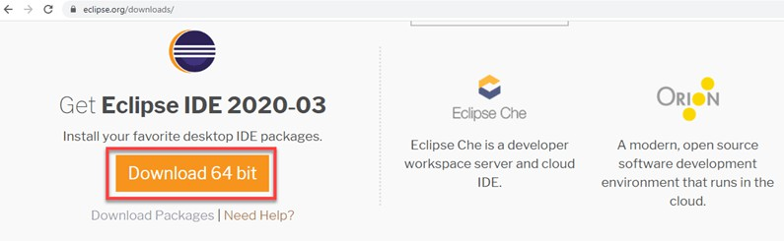

**Step 4) Click on “Download” button**

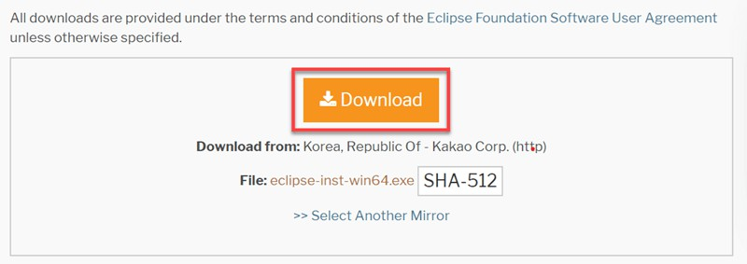

**Step 5) Install Eclipse.**

Click on “downloads” in Windows file explorer.

Click on “eclipse-inst-win64.exe” file.

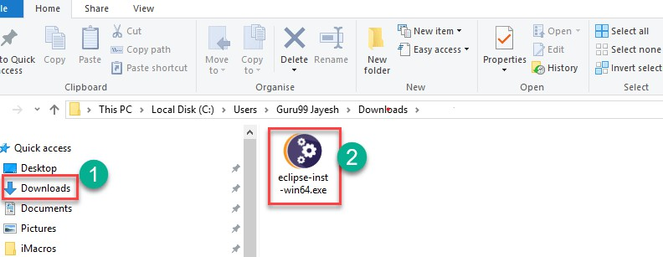

**Step 6) Click on Run button**

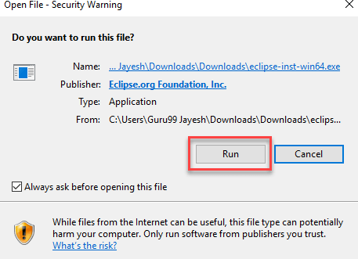

**Step 7) Click on “Eclipse IDE for Java Developers”**

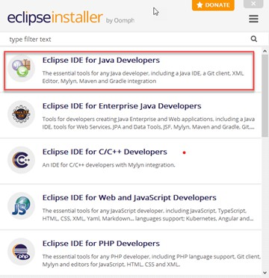

**Step 8) Click on “INSTALL” button**

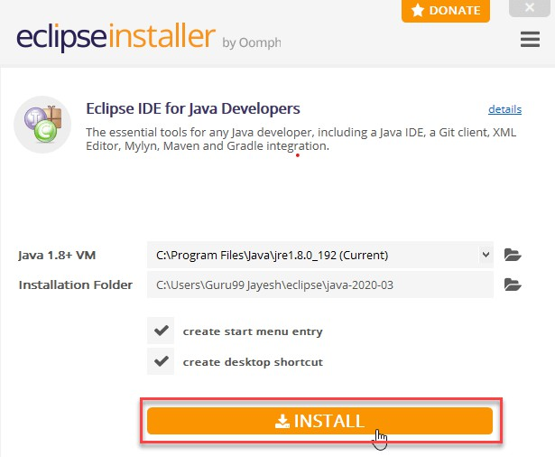

**Step 9) Click on “LAUNCH” button.**

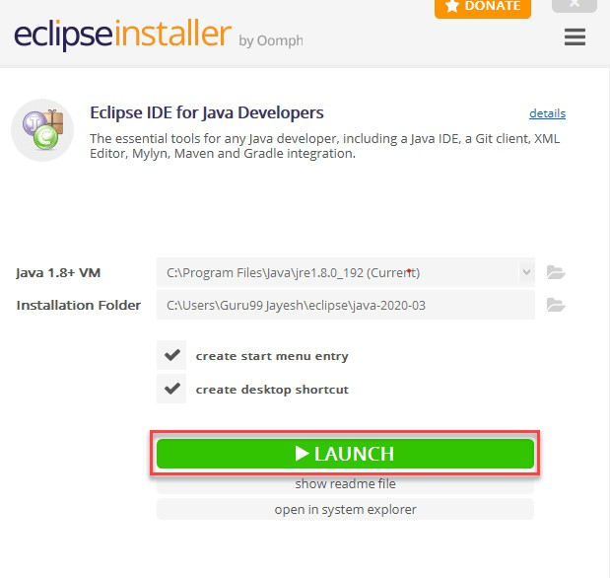

**Step 10) Click on “Launch” button.**

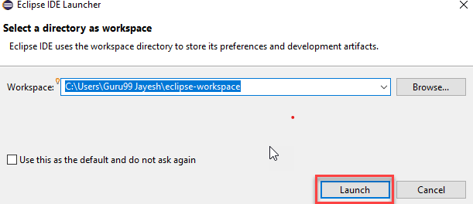

**Step 11) Click on “Create a new Java project” link**.

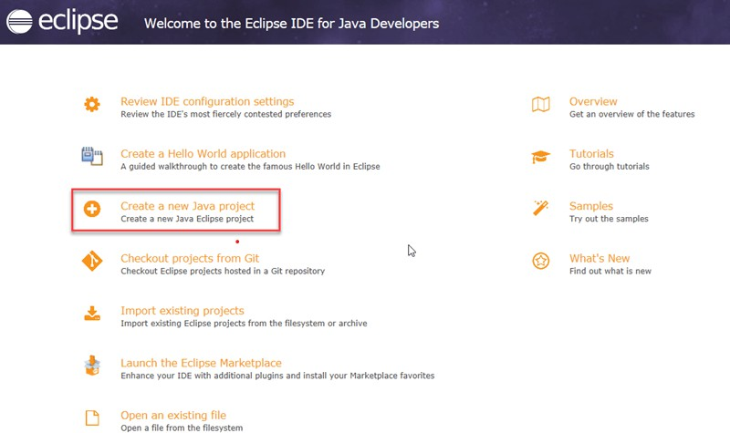

**Step 12) Create a new Java Project**

Write project name.

Click on “Finish button”.

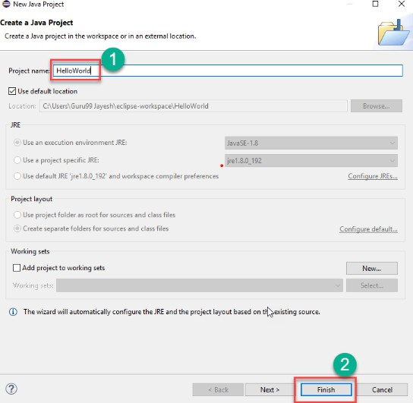

**Step 13)** [**Create Java Package**](https://www.guru99.com/java-packages.html)**.**

Goto “src”. Click on “New”.

Click on “Package”.

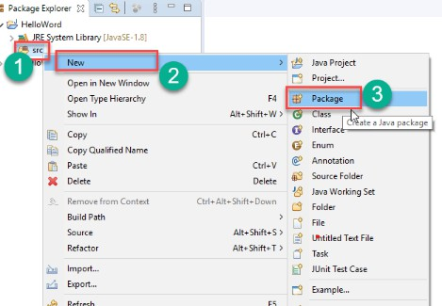

**Step 14) Writing package name.**

Write name of the package Click on Finish button.

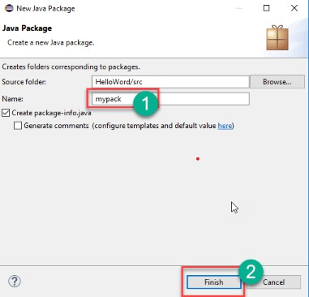

**Step 15) Creating Java Class** Click on package you have created. Click on “New”.

Click on “Class”.

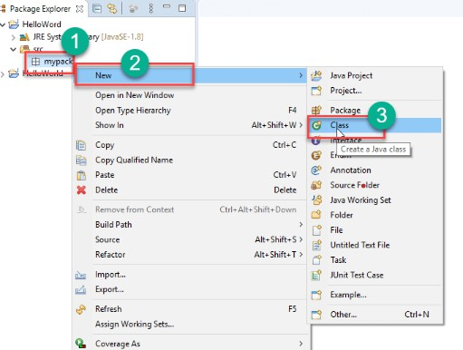

**Step 16) Defining Java Class.**

Write class name

Click on “public static void main (String[] args)” checkbox. Click on “Finish” button

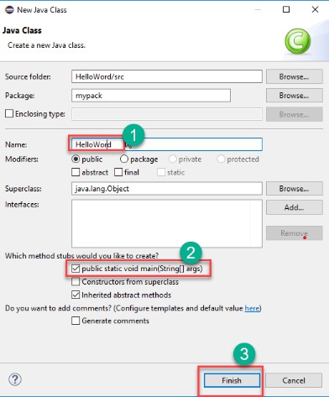

Helloword.java file will be created as shown below:

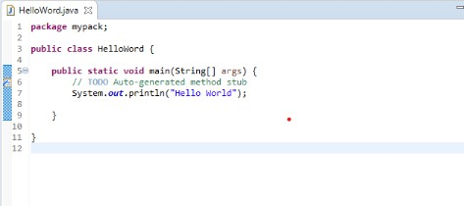

**Step 17) Click on “Run” button.**

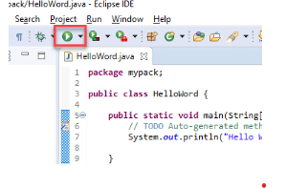

Output will be displayed as shown below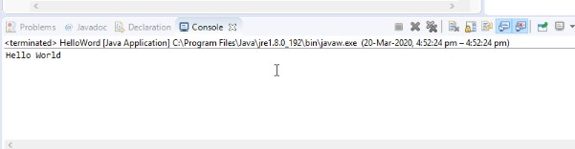.



**A Simple Java Program**

// This program prints Welcome to Java!

public class Welcome {

public static void main(String[] args) { System.out.println("Welcome to Java!");

}

}

**TASK**

**How to Submit**

* Submit lab work in a single pdf/docx on MS Team.
* Submit the work as per format given in this manual (No other format will be accepted).
* Lab work (Exercises) file name should be saved with your roll number and course code (e.g. 21B-001-SE_SExxx_LWxx.pdf where SExxx is course code and LWxx is Lab number).

1. Write a Java program that prints three messages to the console.

package com.company;  
  
// Task - 1  
public class MessagePrinter {  
 public void printThreeMessages() {  
 String[] messages = {"Hello World!", "Welcome to JAVA programming with Syed Muhammad Zaid", "This is lab 3 of software construction & development"};  
 for (String message : messages) {  
 System.*out*.println(message);  
 }  
 }  
}

1. Write a program to take two numbers and print their sum.

package com.company;  
  
public class CalculateSum {  
 public int addTwoNumbers(int num1, int num2){  
 return num1 + num2;  
 }  
}

1. Create programs that print numbers or mathematical expressions to the console.

package com.company;  
  
public class NumberPrinter {  
 public static void printNumbers(){  
 int num1 = 10;  
 int num2 = 20;  
 double numPI = 3.14;  
 System.*out*.println("Printing Numbers:");  
 System.*out*.println("Number 1" + num1);  
 System.*out*.println("Number 2: " + num2);  
 System.*out*.println("Number 3: " + numPI);  
 };  
};

**USING ALL THE ABOVE CLASSES IN A MAIN PROGRAM TO GET THE REQUIRED OUTPUT.**

package com.company;  
  
public class Main {  
 public static void main(String[] args) {  
 // Task - 1 | Using a class from MessagePrinter.java and calling its method named printThreeMessages() to print three messages.  
 System.*out*.println("------------------------- OUTPUT TASK - 1 -------------------------");  
 MessagePrinter messagePrinter = new MessagePrinter();  
 messagePrinter.printThreeMessages();  
  
 // Task - 2 | Using a class from CalculateSum.java and calling its method named addTwoNumbers() to get the result of addition.  
 System.*out*.println("------------------------- OUTPUT TASK - 2 -------------------------");  
 CalculateSum calculateSum = new CalculateSum();  
 int num1 = 10;  
 int num2 = 20;  
 int result = calculateSum.addTwoNumbers(num1,num2);  
 System.*out*.println("The result is: "+result);  
  
 // Task - 3 | Using a class from NumberPrinter.java and calling its method named printNumbers() to print different type of numbers.  
 System.*out*.println("------------------------- OUTPUT TASK - 3 -------------------------");  
 NumberPrinter numberPrinter = new NumberPrinter();  
 numberPrinter.*printNumbers*();  
  
 }  
}

**OUTPUT:**

